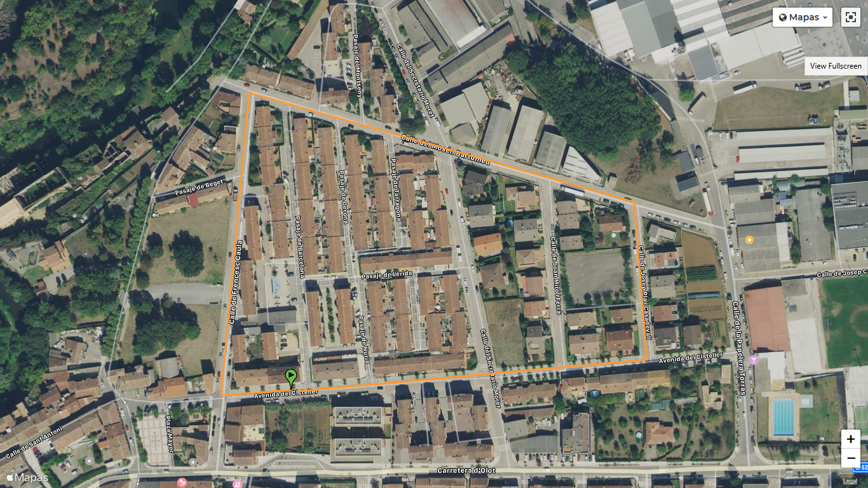
TONDO KIDS CIRCUIT COPA CATALUNYA

